API-COMMUNICATION CONFIGURATION DOCUMENT

Author: Rohit Mainkar
Date: 24-Oct-2022

Table of Contents:

- Purpose
- Outbound API Metadata Configuration
- API Services Configuration
- Webservice Intercept Configuration
- Emailing (Communication) Configuration
- SMS Template Configuration

- Purpose:

This document’s purpose is to help internal users to educate how to do the backend configurations for Incoming-Outgoing data integrations using API Integration, SMS-Email notifications.
This document includes detailed configuration steps for each of these backend configurations

- Outbound API Metadata Configuration:

- For any API Integration, HL development team do the basic configuration such as API Method, API Classes, API service name configuration in the following BO - OutboundAPIMetadata
- Using this BO, we used to configure API related details on below parameters:

Parameter Name (i.e., Column Name) | Description
BO Name | Business Object name on which API Integration has been configured
HTTP Method | API Method based on required operations (i.e., POST, PUT, GET, DELETE)
Service Name | API Integration Name based on nature of the data integration
API Class | API Class details get mentioned here
POJO Class | POJO [Plain Old Java Object] Class details get mentioned here
Disable API | Flag to determine whether API is enabled or disabled
Action | Equivalent DB Operation as per HTTP Method (i.e., ADD, UPDATE, SELECT, DELETE)
Max Retry Attempt | Maximum number of retry attempts for any API request
Retry Interval | Time interval for auto-retry of any fail request
Reference Id | BO column name which contains object related information (i.e., agent_code, receipt_id etc.,)

- In case a new API integration to be configured in this BO, use below steps:
- Login into appropriate Module [i.e., AES/HMS] with appropriate Modeler user
- Go to "Integration Objects"
- Click on Outbound API Metadata (+)
- User will see the following form:

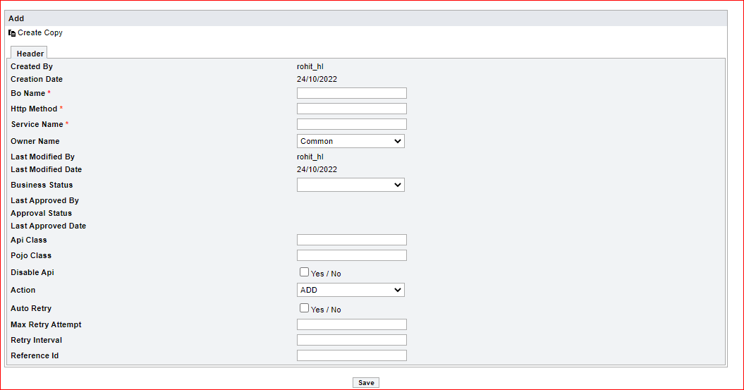

- Fill the appropriate fields and click on Save button as follows:

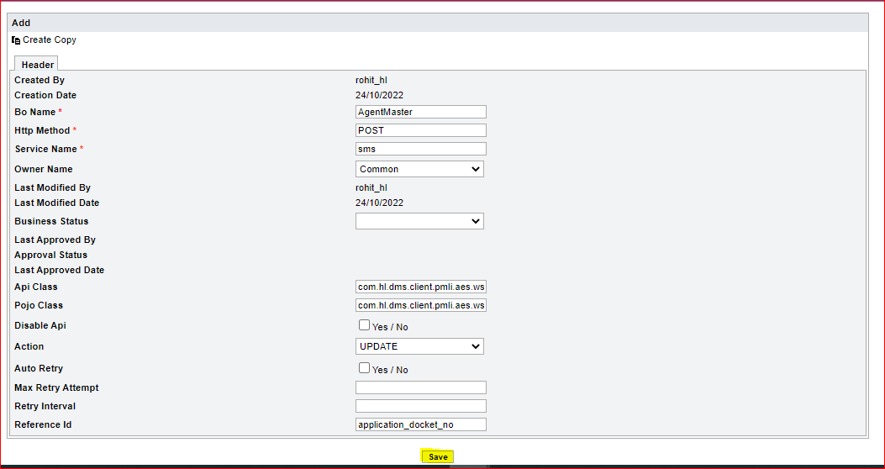

Note:
>> API Class and POJO Class information is provided by DMS Development Team
>> In case of any issues related to this BO Configuration, kindly contact with DMS Development Team

- In case user wants to update existing configuration details, then follow the below steps:
- Login into appropriate Module [i.e., AES/HMS] with appropriate Modeler user
- Go to "Integration Objects"
- Click on 'Outbound API Metadata' option
- Click on 'New Search' as follows:

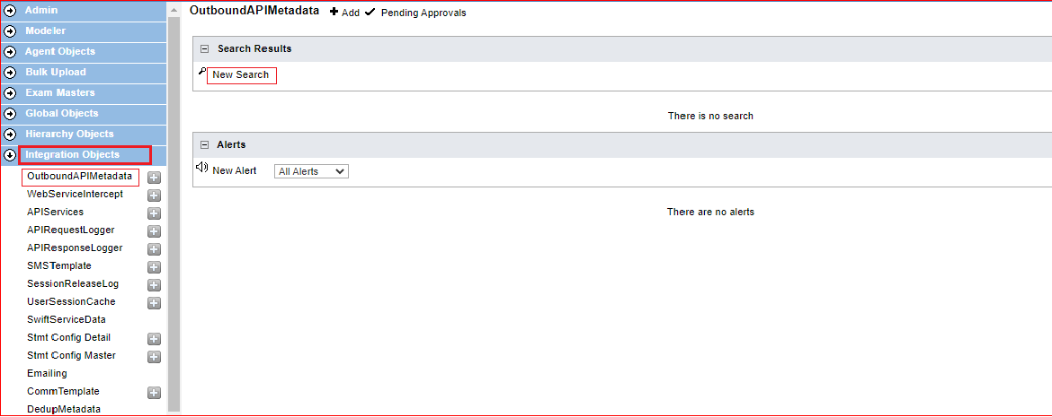

- Then select appropriate Property and then click on Submit to get filtered data
- User can even directly click on Submit as follows to get entire details

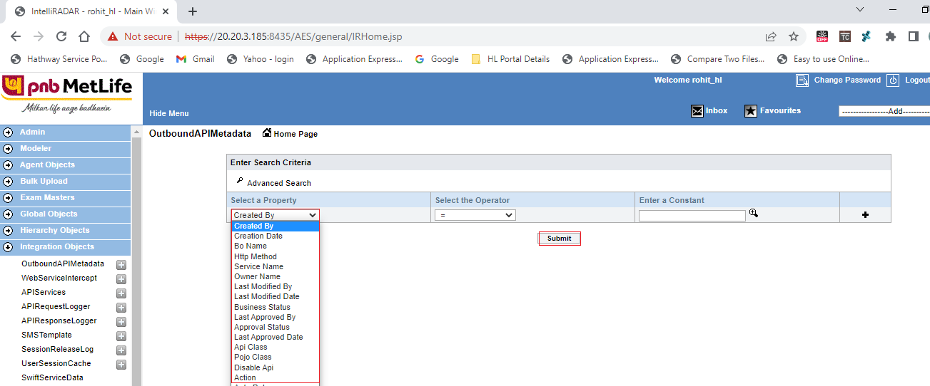

- Post the submit action, user will see the below details:

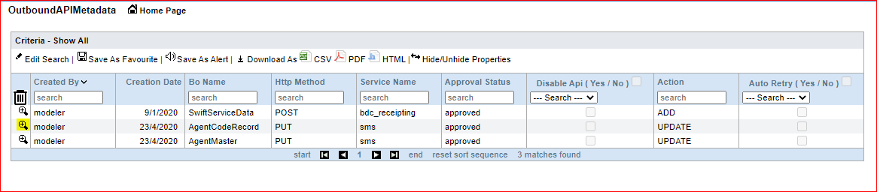

- Open the appropriate record simply by clicking on (+) - Magnifier glass which is placed before the required record
- User will see the below details as follows:

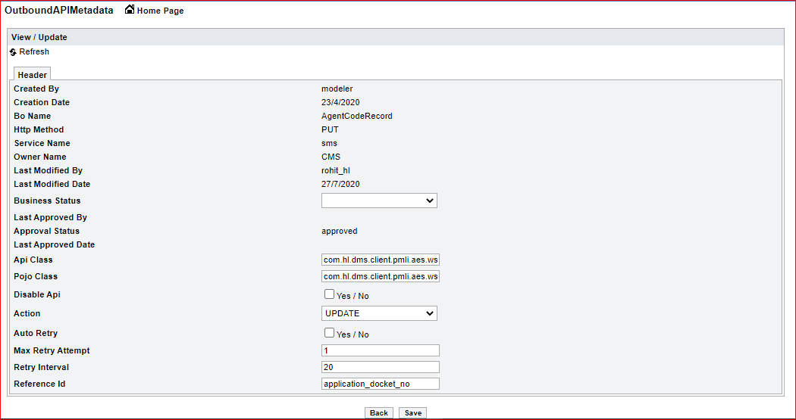

- Make the changes in the appropriate field(s) and Click on Save as follows:

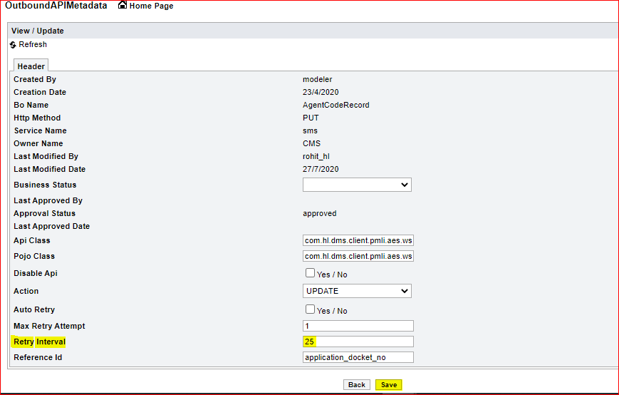

- API Services Configuration:

- Below is the description of APIServices BO
- Using this BO, we used to configure the API Services based on below parameters:

Parameter Name (i.e., Column Name) | Description
service_name | API Service Name provided by Internal dev team / client
content_type | Media type of the resource. In most of REST API, default value - application/json
authorization | It is used to identify and verify, whether user is eligible/entitled to access a server resource or not
api_url | End point. Address that allows you to access the API and its features.
token_service_name | Service which provides a respective token (if any) to execute a main API
custom_headers | Headers get captured here with comma separated format. It contains more information about the resources to be fetched.
custom_headers_values | Values of custom_headers get captured here with comma separated format

- In case a new API Service to be configured in this BO, use below steps:
- Login into appropriate Module [i.e., AES/HMS] with appropriate Modeler user
- Go to "Integration Objects"
- Click on API Services (+)
- User will see the following form:

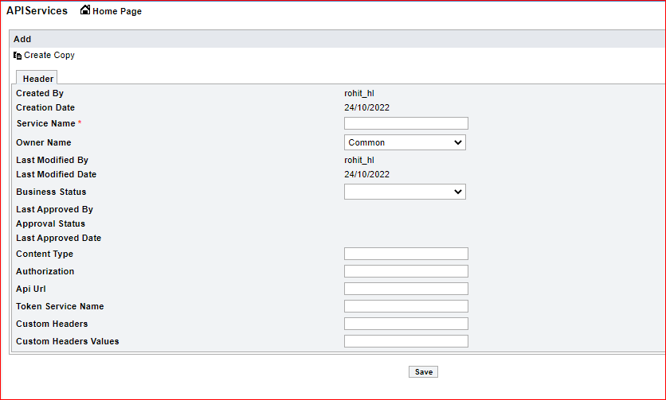

- Fill the appropriate fields and click on Save button as follows:

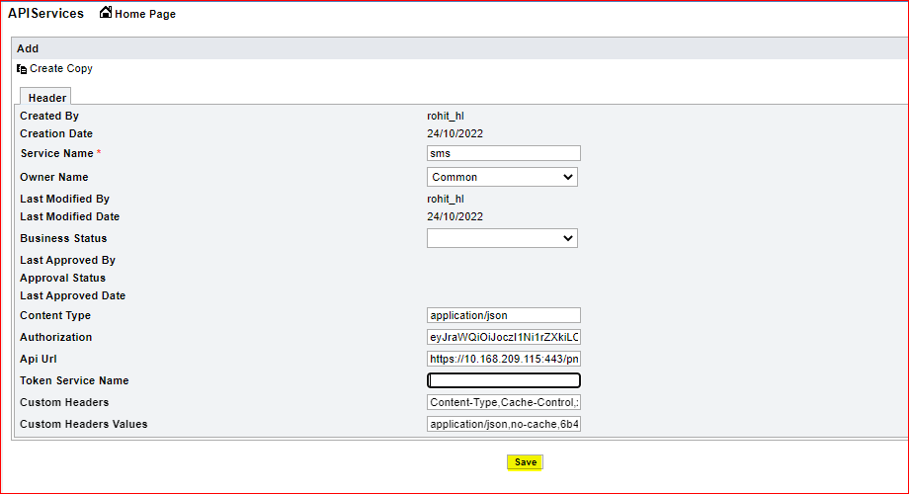

Note:
>> API URL, Custom Headers, Custom Headers values etc., information is provided by Client Team
>> In case of any issues related to this BO Configuration, kindly contact with DMS Development Team

- In case user wants to update existing configuration details, then follow the below steps:
- Login into appropriate Module [i.e., AES/HMS] with appropriate Modeler user
- Go to "Integration Objects"
- Click on 'API Services' option
- Click on 'New Search' as follows:

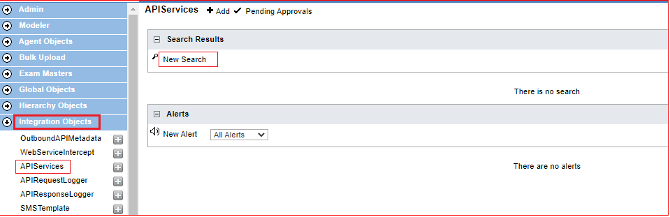

- Then select appropriate Property and then click on Submit to get filtered data
- User can even directly click on Submit as follows to get entire details

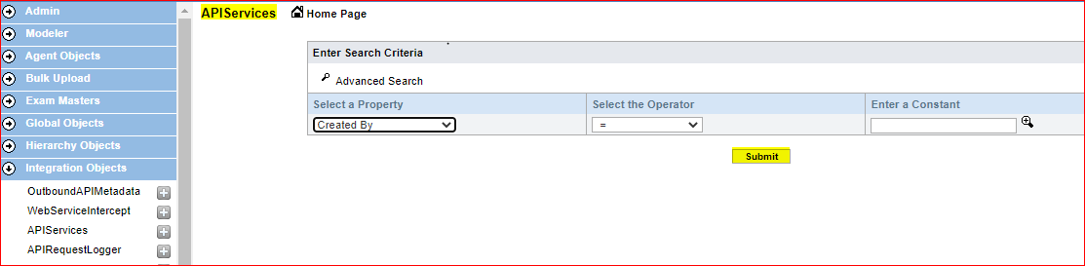

- Existing details will be displayed in following format:

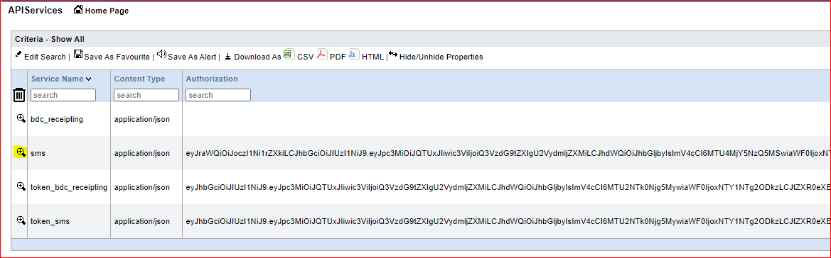

- Open the appropriate record simply by clicking on (+) - Magnifier glass which is placed before the required record
- User will see the below details as follows:

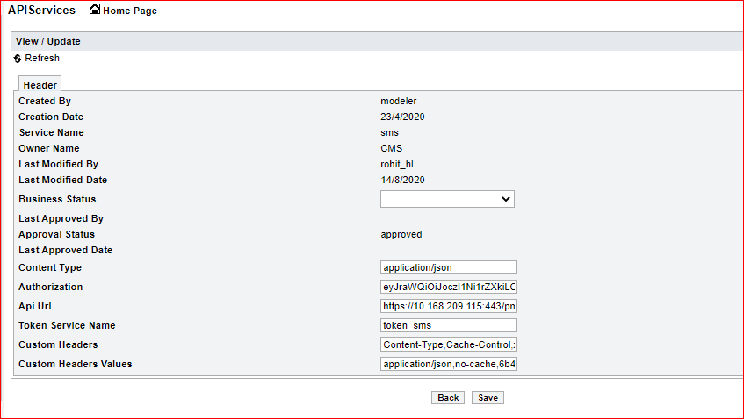

- Make the changes in the appropriate field(s) and Click on Save as follows:

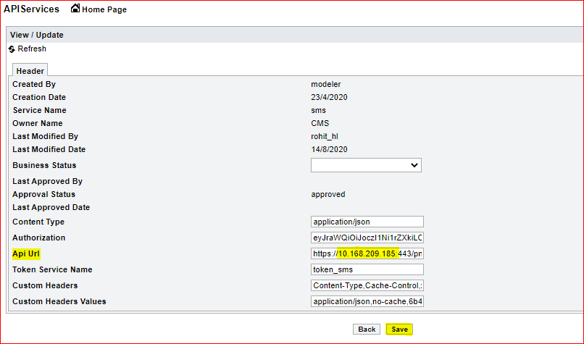

- Webservice Intercept Configuration

- Web services are configured in the following BO: WebServiceIntercept
- Using this BO, we used to configure the API based on below parameters:

Parameter Name (i.e., Column Name) | Description
bo_name | Business Object (BO) name on which the respective Web Service is configured
property_name | Required column of Business Object (BO)
property_alias_name | Alias (i.e., NickName) to be provided for particular column of Business Object (BO)
http_method | Appropriate method name as per the functionality of particular Web Service (API)
webservicename | Appropriate name given for particular Web Service
is_mandatory | Filed to identify whether the required column details are mandatory or not
is_hidden | To make the column either hidden or to make it available for JSON structure
default_value | To provide default value (if any) for respective column

- In case of new field to be passed in particular Web Service (i.e., API), then we need to add that field in WebServiceIntercept BO along with above parameter values
- Login into appropriate Module [i.e., AES/HMS] with appropriate Modeler user
- Go to "Integration Objects"
- Click on WebServiceIncercept (+)
- Fill the appropriate details and click on "Save" as follows:

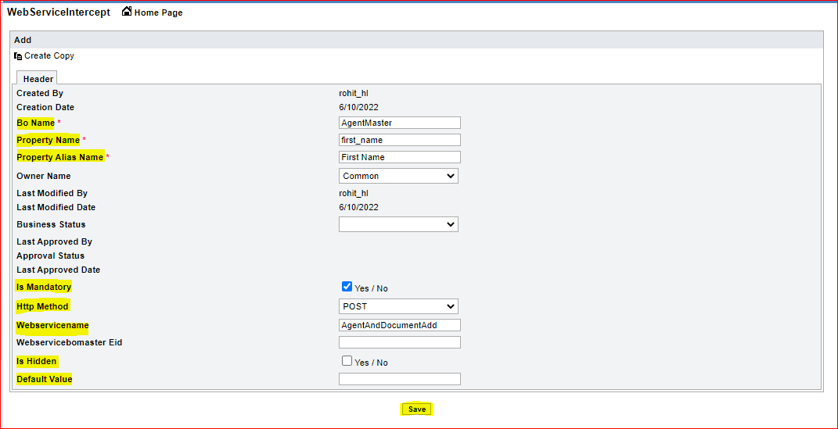

Note:
i) In case no alias to be given, you can put Property Name in Property Alias Name field also
(i.e., you can put "first_name" in property alias name column as well)
ii) Default value to be provided in case you want to keep this property as Hidden
iii) In that case, "Is Hidden" flag will be 1 (i.e., Ticked) and default value will be provided

- Emailing (Communication) Configuration

- Below is the description of CommConfiguration BO
- Using this BO, we used to configure the SMS and/or Email Communication based on below parameters:

Parameter Name (i.e. Column Name) | Description
BO Name | Business Object name on which SMS communication has been configured
Field Name | Actual Column name on which SMS/Email communication has been configured
LOV Name | Actual field value based on which SMS/Email communication gets triggered
Attachment Template | Template to be attached, if any *
SMS Template | Appropriate SMS Template Id (applicable for SMS communication only)
SMS | Flag to determine whether SMS communication is required or not
To Email Address | Recipients Configuration field *
CC Email Address | CC Emails configuration field *
Subject | To define the Email Subject *
Body | To define the Email Body *

* These fields are mandatory while setting up Email Configuration only

- In case a new Communication to be configured in this BO, use below steps:
- Login into appropriate Module [i.e. AES/HMS] with appropriate Modeler user
- Go to "Integration Objects"
- Click on Emailing option
- User will see the following form:

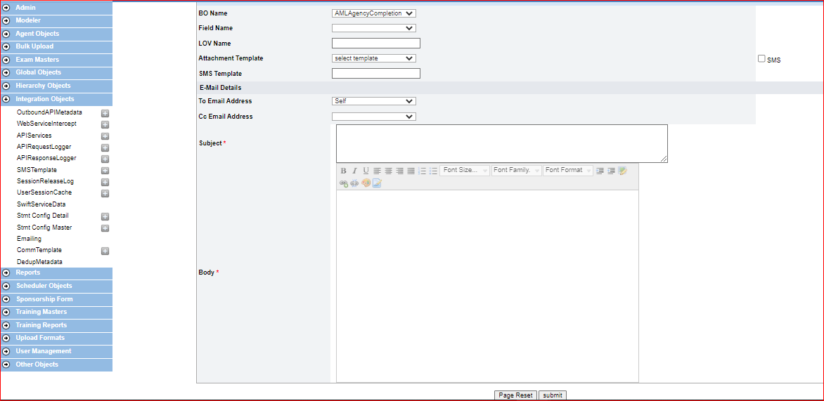

- Fill the appropriate details and click on submit.
- Below is example of one of the SMS Communication set up

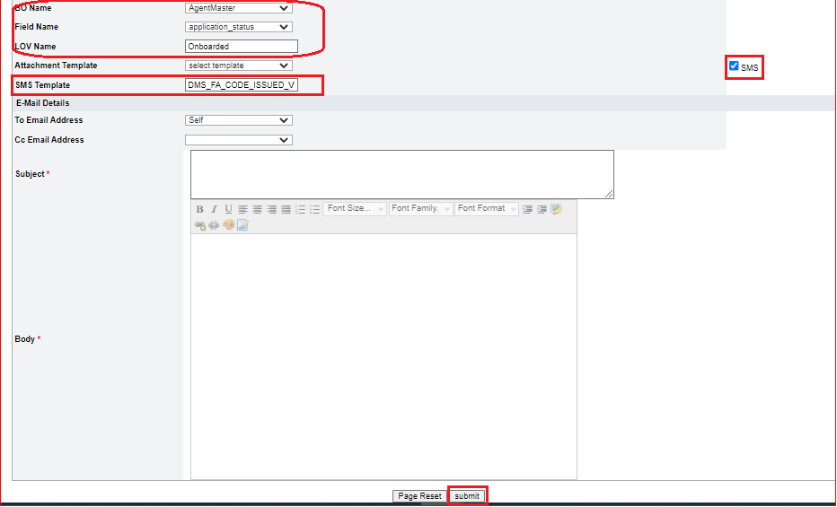

- Below is example of one of the Email Communication set up

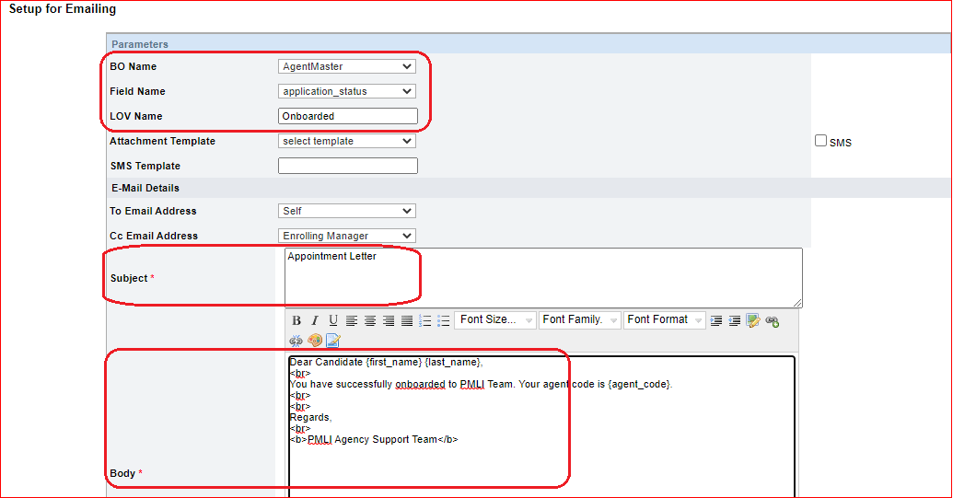
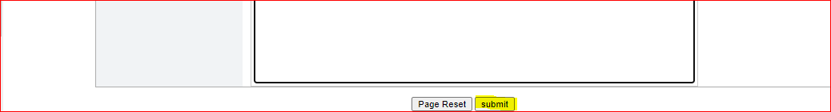

- Similarly, we can configure n number of SMS and/or Email Communication configurations here.
- Once we add the configurations here, the details get stored in DB at below location

Table Name | Environment | AES Schema Name | HMS Schema Name
CommConfiguration | Production (i.e., PROD) | pml_aes_dev | pml_hms_dev
CommConfiguration | UAT | pml_aes_uat | pml_hms_uat
CommConfiguration | SIT (i.e., DEV) | pmli_aes_dev | pmli_hms_dev

- SMS Template Configuration

- Below is the description of SMSTemplate BO
- Using this BO, we used to configure the Template details based on below parameters:

Parameter Name (i.e., Column Name) | Description
template_id | Template Name provided by client
bo_name | Business Object name on which respective SMS Template is configured
metadata_properties | It is used to provide the field details in predefined manner which are requested to be shared in respective SMS template

- In case a new SMS template to be configured in this BO, use below steps:
- Login into appropriate Module [i.e., AES/HMS] with appropriate Modeler user
- Go to "Integration Objects"
- Click on SMS Template (+) option
- User will see the following form:

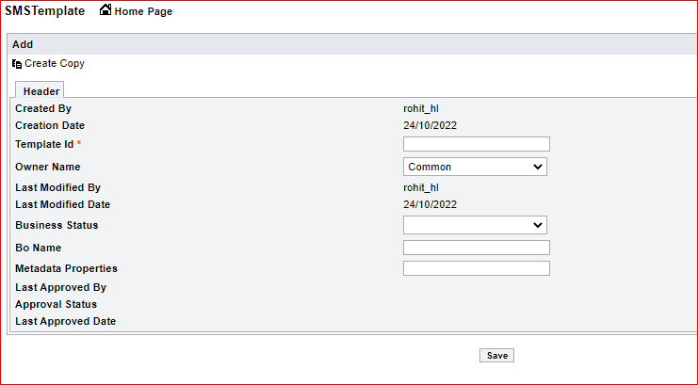

- Fill the appropriate fields and click on Save button as follows:

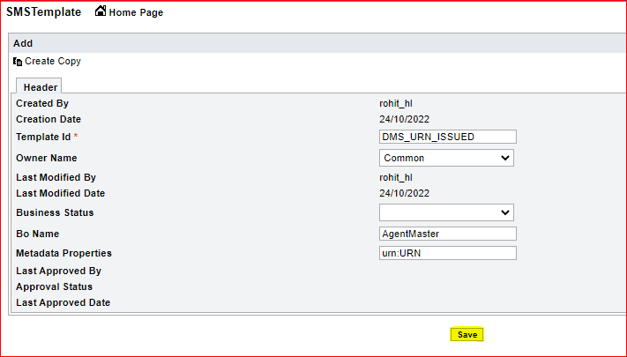

- Format of Metadata properties field is as follows:

{bo_property_name}:{json_metadata_property_name}

e.g.
urn:URN_NO
application_docket_no:RECRUITMENT_KIT_NO
agent_code:FA_CODE
etc.,

- Once we add the configurations here, the details get stored in DB at following table
Table Name - SMSTemplate

- Existing Template details (which are IN USE) and their description is as follows:

Template_id | Description
DMS_URN_ISSUED_V2 | Used to send notification after successful URN Generation
DMS_URN_NOT_ISSUED_V2 | Used to send notification after unsuccessful URN Generation
DMS_FA_CODE_ISSUED_V2 | Used to send notification after successful Code creation
DMS_AML_ACTIVATION_V2 | Used to send notification once the CODE creation as well as CST Training gets completed both

Note:
>> Template ID information is provided by PMLI Development Team
>> In case of any issues related to this BO Configuration, kindly contact with DMS Development Team

- In case user wants to update existing configuration details, then follow the below steps:
- Login into appropriate Module [i.e., AES/HMS] with appropriate Modeler user
- Go to "Integration Objects"
- Click on 'SMS Template' option
- Click on 'New Search' as follows:

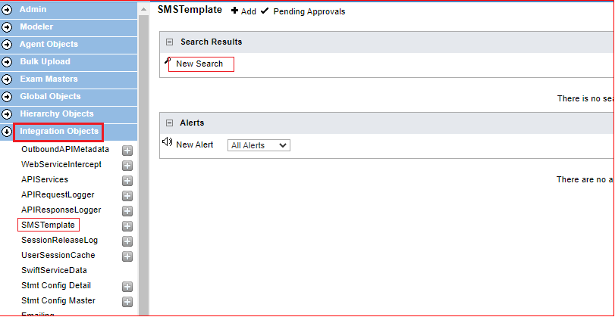

- Then select appropriate Property and then click on Submit to get filtered data
- User can even directly click on Submit as follows to get entire details

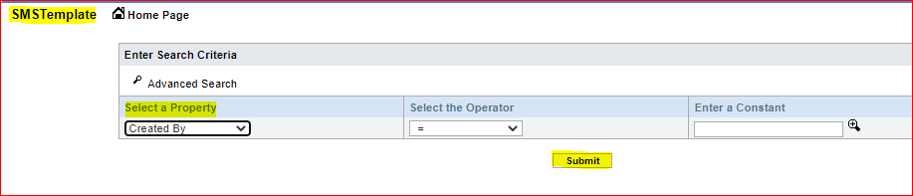

- Post the submit action, user will see the below details:

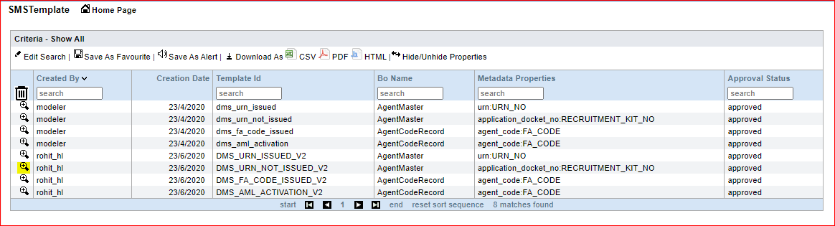

- Open the appropriate record simply by clicking on (+) - Magnifier glass which is placed before the required record
- User will see the below details as follows:

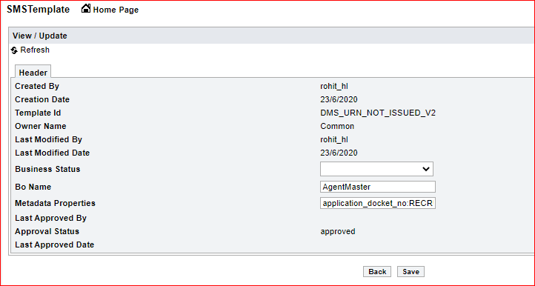

- Make the changes in the appropriate field(s) and Click on Save as follows:

